Assignment-1 Solution
Name : Smit Makwana
Roll No : 241021

Task A – Voltage Divider Measurement Module
Using two resistors in series, it produces an output voltage that is a predictable
fraction of the input voltage.
Theoretical formula:
Vout = Vin × (R2 / (R1 + R2))
The Arduino reads the divided voltage through its 10-bit ADC.
ADC-to-voltage conversion:
V = ADC × (5.0 / 1023)
For (10kΩ-10kΩ)
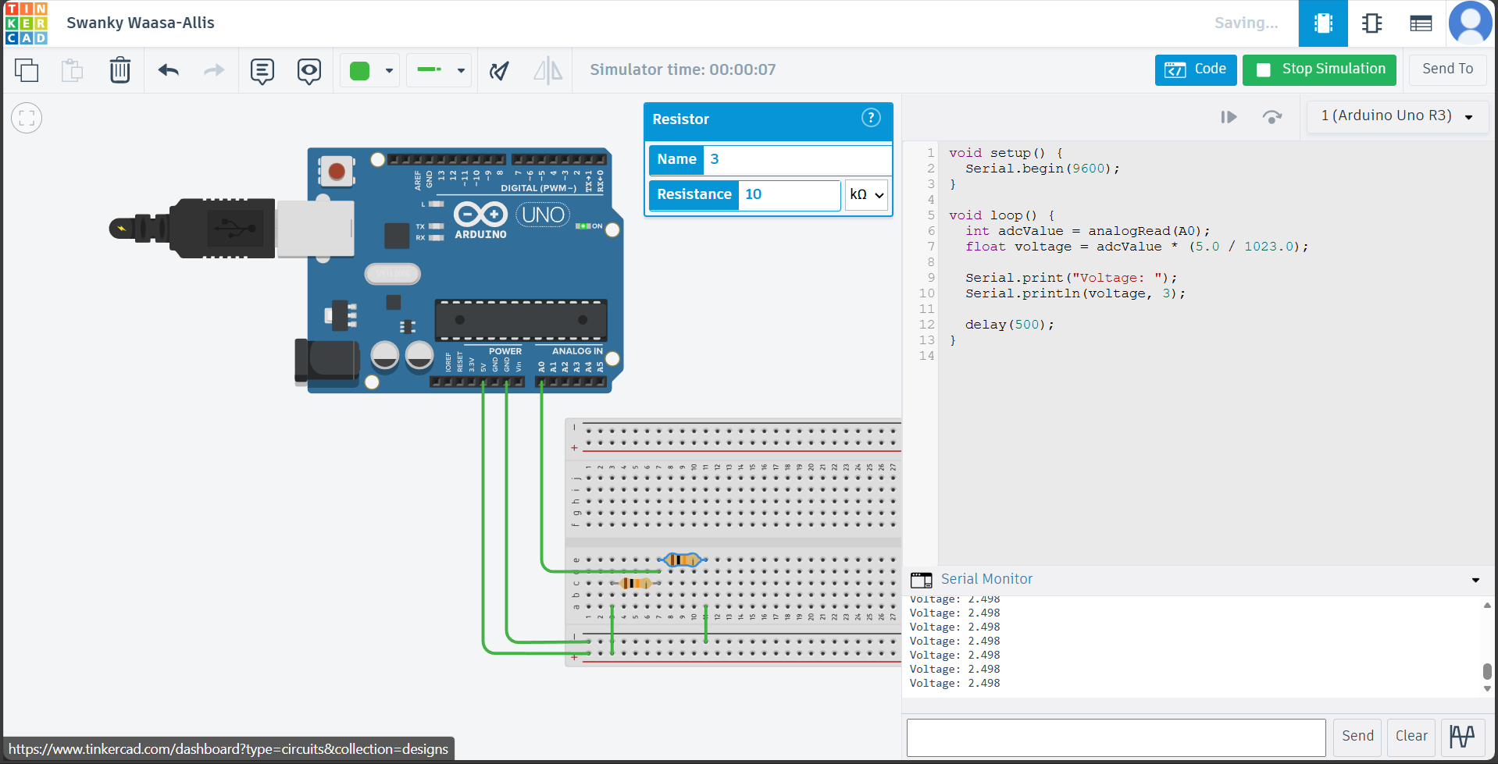For (4.7kΩ-10kΩ)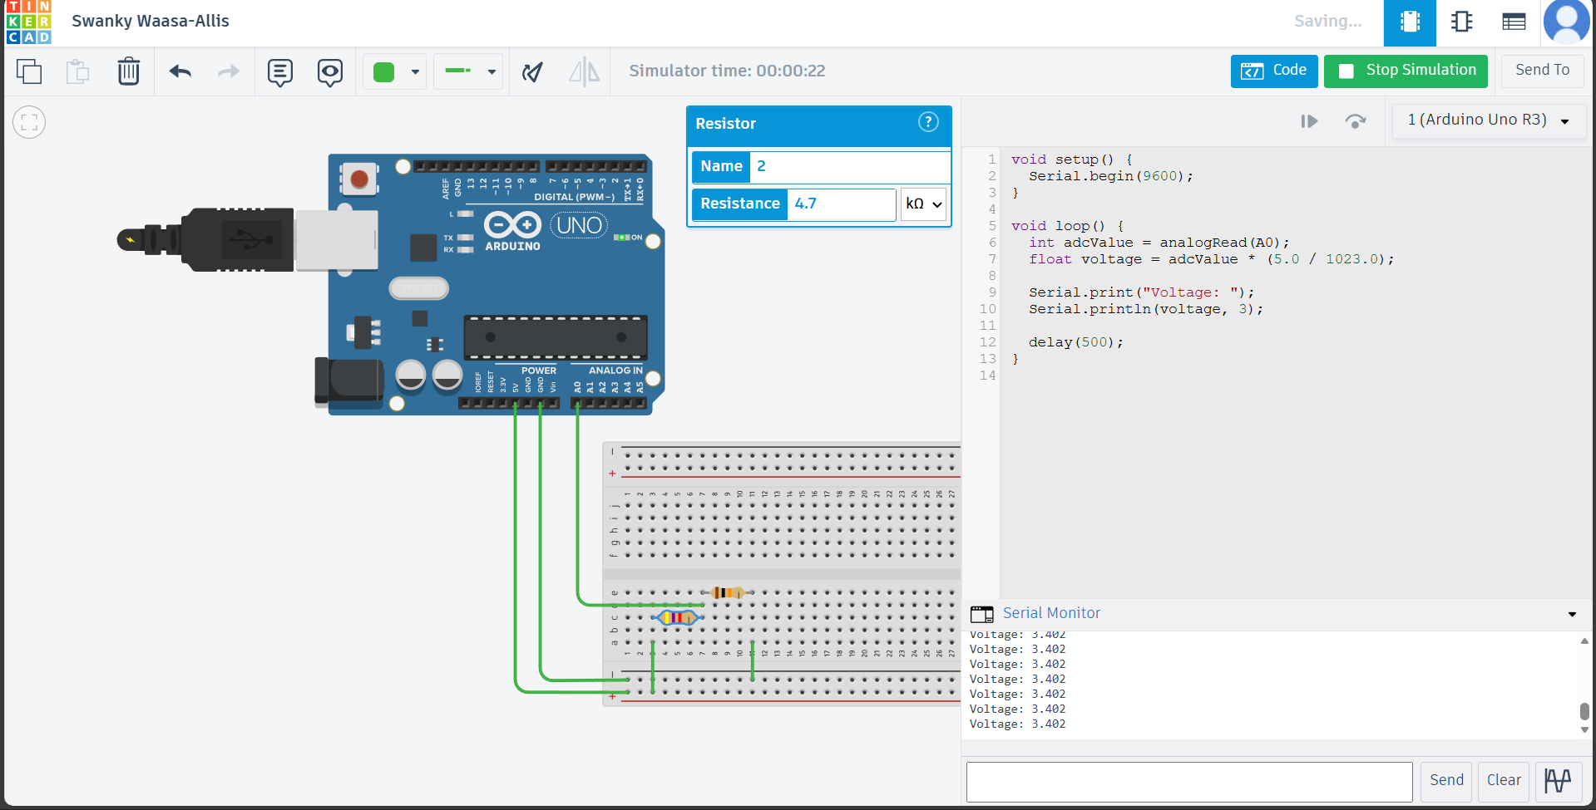
For (1kΩ-15kΩ)
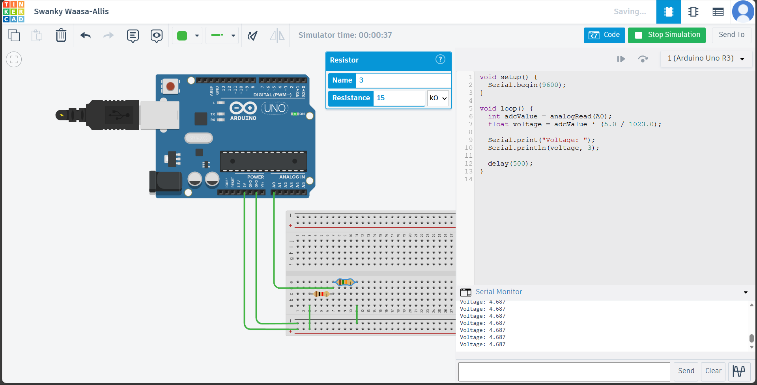
Voltage Divider – Theoretical vs Measured Table
R1 (kΩ) | R2 (kΩ) | Theoretical Vout (V) | Measured Vout (V) | Error (%)
10 | 10 | 2.5 | 2.498 | 0.08
4.7 | 10 | 3.401 | 3.402 | 0.029
1 | 15 | 4.687 | 4.687 | 0

Arduino Code Excerpt for Voltage Measurement
void setup() {
Serial.begin(9600);
}
void loop() {
int adcValue = analogRead(A0);
float voltage = adcValue * (5.0 / 1023.0);

Serial.print("Voltage: ");
Serial.println(voltage, 3);
delay(500);
}
Task B – Capacitance Measurement Using RC Time Constant
When a capacitor charges through a resistor, the voltage across it rises exponentially.
At exactly one time constant (τ = R × C), the capacitor reaches 63.2% of the supply voltage.
This property allows us to measure capacitance by timing the charge interval.
Capacitance calculation:
C = t / R
The Arduino uses analogRead() to monitor voltage and micros() to measure time.
For C = 1 µF
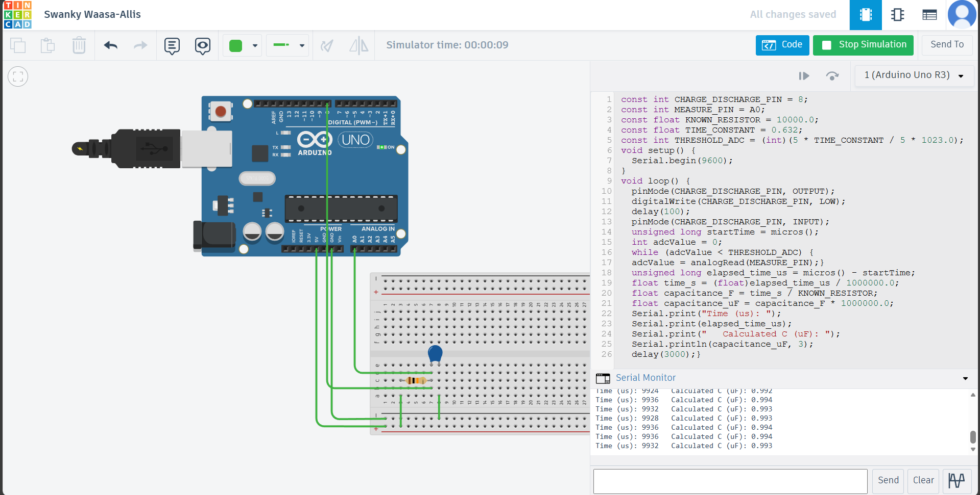
For C = 10 µF
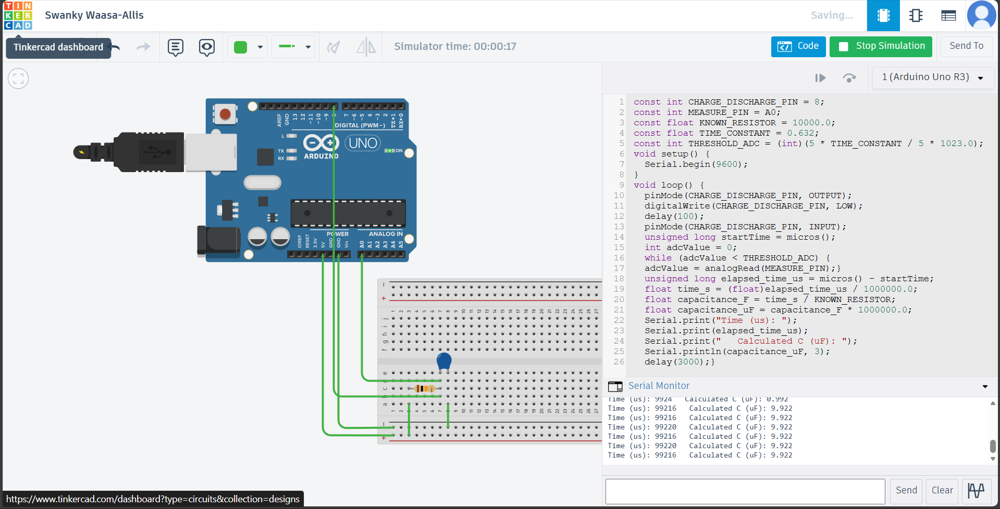
Capacitance Measurement Table
Capacitor (µF) | Expected Time (ms) | Measured Time (ms) | Calculated C (µF) | Error (%)
1 | 10 | 9.932 | 0.993 | 0.7
10 | 100 | 99.216 | 9.922 | 0.78
Arduino Code Excerpt for Capacitance Measurement
const int CHARGE_DISCHARGE_PIN = 8;
const int MEASURE_PIN = A0;
const float KNOWN_RESISTOR = 10000.0;
const float TIME_CONSTANT = 0.632;
const int THRESHOLD_ADC = (int)(5 * TIME_CONSTANT / 5 * 1023.0);
void setup() {
Serial.begin(9600);
}
void loop() {
pinMode(CHARGE_DISCHARGE_PIN, OUTPUT);
digitalWrite(CHARGE_DISCHARGE_PIN, LOW);
delay(100);

pinMode(CHARGE_DISCHARGE_PIN, INPUT);

unsigned long startTime = micros();
int adcValue = 0;
while (adcValue < THRESHOLD_ADC) {
adcValue = analogRead(MEASURE_PIN);
}
unsigned long elapsed_time_us = micros() - startTime;

float time_s = (float)elapsed_time_us / 1000000.0;
float capacitance_F = time_s / KNOWN_RESISTOR;
float capacitance_uF = capacitance_F * 1000000.0;

Serial.print("Time (us): ");
Serial.print(elapsed_time_us);
Serial.print(" Calculated C (uF): ");
Serial.println(capacitance_uF, 3);

delay(3000);
}
Task C – Beginner Ohmmeter Prototype
An ohmmeter determines an unknown resistor by forming a voltage divider with a known
reference resistor. By measuring the midpoint voltage, the unknown resistance can be computed.
Formula:
R_unknown = R_ref × (Vin / Vout - 1)
For R unknown = 1
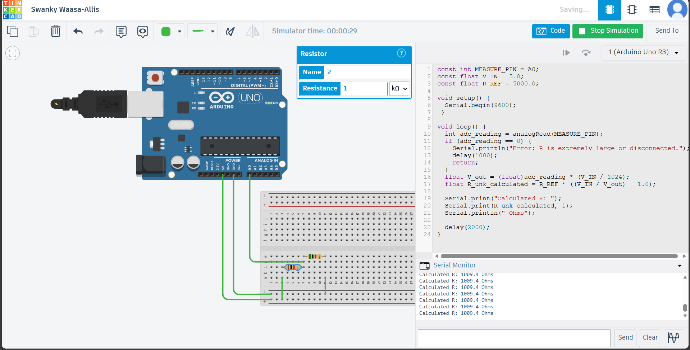
For R unknown = 5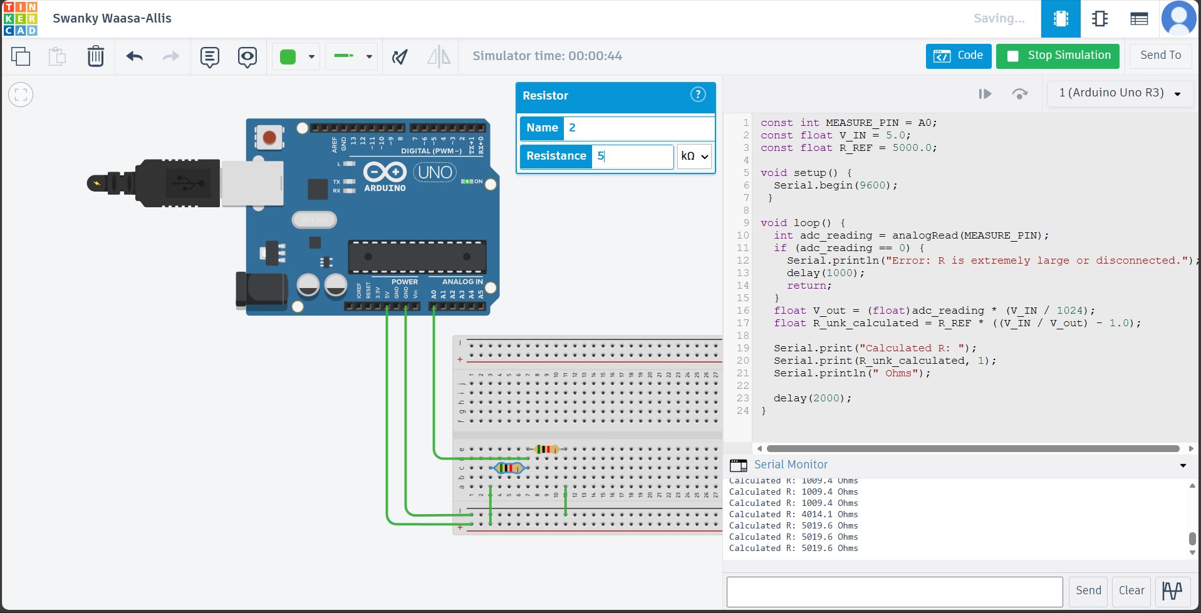’For R unknown = 10
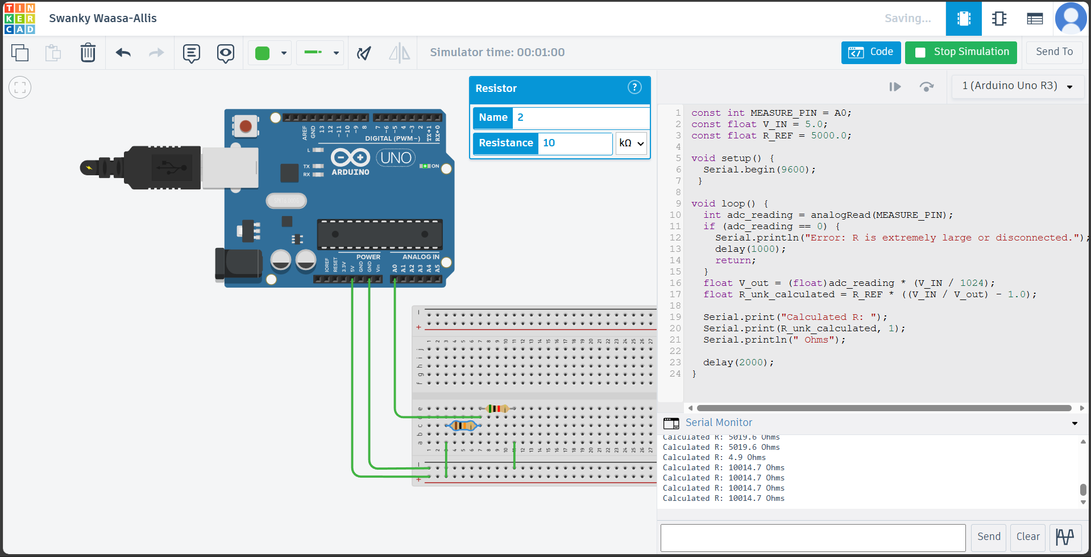
Ohmmeter – Actual vs Measured Values
Actual R (Ω) | Measured R (Ω) | Error (%)
1000 | 1009.4 | 0.94
5000 | 5019.6 | 0.392
10000 | 10014.7 | 0.147
Arduino Code Ohmmeter
const int MEASURE_PIN = A0;
const float V_IN = 5.0;
const float R_REF = 5000.0;

void setup() {
Serial.begin(9600);
}

void loop() {
int adc_reading = analogRead(MEASURE_PIN);
if (adc_reading == 0) {
Serial.println("Error: R is extremely large or disconnected.");
delay(1000);
return;
}
float V_out = (float)adc_reading * (V_IN / 1024);
float R_unk_calculated = R_REF * ((V_IN / V_out) - 1.0);

Serial.print("Calculated R: ");
Serial.print(R_unk_calculated, 1);
Serial.println(" Ohms");

delay(2000);
}
Discussion of Errors
The Arduino’s 10-bit ADC divides 0–5 V into 1024 steps (approx 4.88 mV per step).
This causes small jumps in measured voltage, especially in mid-range values and cannot detect changings smaller than 4.88 mV.
Real resistors (±5%) and capacitors (±10–20%) rarely match their printed values.
This leads to mismatch between theoretical and measured outputs even in TinkerCAD.
Multimeters use multiple ranges and attenuators but here my circuit uses only one range, leading to less accuracy and poor performance at extremes.
The resistor and capacitance are not ideal implies their actual values may not match the values written on them. So, an error can be seen in the RC time constant and the measured τ.
The analog voltage readings can vary and affect the measured values due to the noise of VSB power supply and breadboard connections.
Some Arduino function has its own resolution and can lead to the small errors in measured values in certain circumstances for example micros().
Conclusion
This Assignment help us to apply Ohm’s Law and voltage divider principles and allows us to implement it to measurement circuits. It also deepens the understanding and use of the Arduino ADC to convert analog voltages into digital value by implementing in the problem statement itself. It allows us to enhance understanding the concept of RC time constant and how to measure it effectively and correctly. Overall, this assignment strengthened my foundation not only in Arduino-based measurement techniques but also in the mindset required to build reliable electronic systems.

